HORACE GLEDHILL

Born: 3rd November 1887 in BURLEY IN WHARFEDALE and baptised on 20th November at St Mary the Blessed Virgin Church, the son of Walter Gledhill and Rebecca
Siblings: Isabel, Hilda, Carrie, Horace, Lucy, Alice May and George Brumfitt Gledhill
The 1891 census tells us the family resided at 157 MAIN STREET, BURLEY near OTLEY. His father, Walter is a Certificated Teacher of a school. The children are all described as scholars. Their aunt, Lucy Hirst was staying with them on the night of the census
In 1901 the family are living at SCHOOL HOUSE, DACRE where Walter’s father has taken up a post as Schoolmaster. Horace is 13
The 1911 census finds Horace in KIRKBY OVERBLOW working as farmer’s man for the family of Joseph Harper. Horace is single
On the 6 July 1911 he set sail from Liverpool aboard the Suevic, (White Star Liner) for Sydney, Australia
Private 3834 Horace Gledhill enlisted on 23 November 1915 with the Australian Infantry and was placed into the 51st (West Australian) Infantry Battalion. His service records confirm he was a pupil at Braithwaite Endowed School, Dacre Banks. His record also says he is a farmer and he had trained as a school teacher. His mother’s home address is 87 Harrogate Road, Chapel Allerton, Leeds. His two younger brothers, Walter and George Brumfitt Gledhill also enlisted, as did his cousin George Frederick Dale, he also emmigrated to Perth, Australia. Frederick Dale died in battle on 19 September 1915. Their mothers’ were sisters. His brothers’ survived the war

Horace was killed at the Somme on 16 August 1916. He was aged 28. ‘He was killed by a shell and was so mutilated that he could not be recognised along with seven others of the 13th Battalion. A further twenty thousand were dead and forty thousand wounded and missing on that day’
He is commemorated at Serre Road Cemetery No.2 together with Memorials in Nidderdale, HOOKSTONE MEMORIAL ROLL OF HONOURS, ST SAVIOUR’S CHURCH, THORNTHWAITE DACRE BRAITHWAITE ROLL OF HONOURS, AND A ROLL OF HONOURS AT NIDDERDALE MUSEUM, PATELEY BRIDGE (a copy of the latter also hangs at Hookstone Memorial Hall

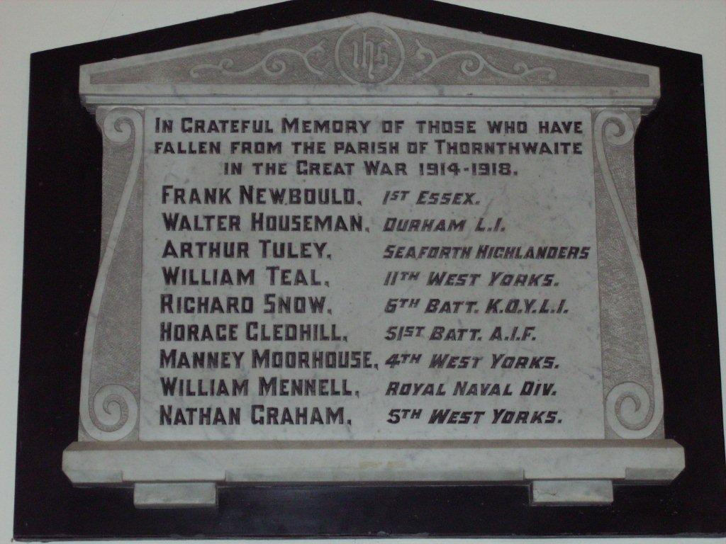
HOOKSTONE MEMORIAL HALL PLAQUE

