FRANK NEWBOULD

Born: June Quarter 1882 (Volume 9a/Page 67 Pateley Bridge) in Birstwith the third child of Samuel Newbould and Martha Hors(e)man
Siblings: Clara, Harry, and younger brotherAllan
The 1891 census tells us the family resided at FOLLY HALL, LEEMING LANE THORNTHWAITE He is 9 and the son of a farmer.
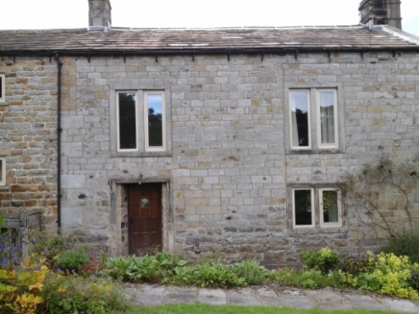
FOLLY HALL, LEEMING LANE, THORNTHWAITE

In 1901 Frank is described a servant/ agricultural labourer at VOLTA HOUSE, DAY LANE, DARLEY
The 1911 census finds him in PADSIDE, DACRE with his parents, brother, Harry and Uncle William Tuley. Frank is 28, single and a farmer’s son working on the farm
His brother, Allen died in Canada in 1909
His father, of Padside Farm, Padside, passed away on 12 September 1920 and left his effects of £973 18s 11d to his son Harry Newbould, farmer

Frank Newbould was a Private in the Essex Regiment, 1st Battalion. His service number was 49805. Formerly 4400 West Yorkshire Regiment.
The 1914 – 1918 Thornthwaite Valuation describes him as a Sapper and householder and an Absent Voters register, 300061, D.Coy, 14th Platoon with 7th Notts and Derby Regiment

His service took him to Western Europe. He died from his wounds in France and Flanders on 8 October 1918 aged just 32. He received both the Victory Cross and British Medal for his service.
