NATHAN GRAHAM
B: March Quarter 1885 (Volume (9a/Page 59 Pateley Bridge). His mother was Margaret Ann Graham
Siblings: Alfred his brother and John H his half brother
At the time of the 1881 census Nathan had not been born. His mother is living with the Postlethwaite family at 6 HIGH ROW, HARTWITH. She is described as a stepdaughter, aged 19 and working as a flax mill hand
In the 1891 census Nathan and his mother are paupers in UNION WORKHOUSE, BISHOPSIDE, PATELEY BRIDGE. His mother is 27 and a mill hand. Nathan is a scholar
By the time of the 1901 census his mother has married THOMAS SAVILLE in the June Quarter of 1895 (Volume 9a/Page 103). Nathan is 17 and they are living at 46 BLYTH STREET, CONISBROUGH near DONCASTER. Nathan is a coal miner
At the time of the 1911 census Nathan and his mother are back in the dales at MALT KILN, DARLEY. His mother is the head of the household and a widow. Nathan is single and a general labourer.
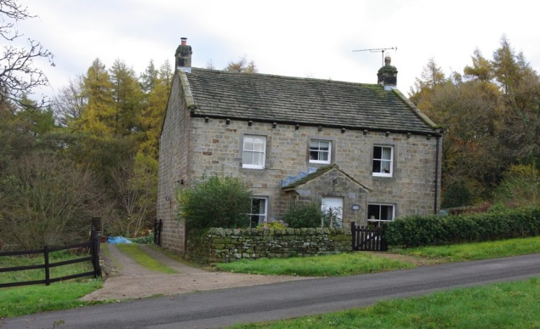
MALT KILN, DAY LANE, DARLEY
Nathan’s service numbers are recorded as 5477, 202524 a Private with Prince of Wales Own (Yorkshire Regiment).
He was killed by a sniper in action at Leipsig Salient on the Somme on 16 August 1916.
The War Diary for the day reads ‘Quiet day in Salient. All companies repairing trenches where damaged by trench mortars. Front line companies putting out wire. Casualties 3 OR wounded (suffering from shell-shock), 1 OR killed 3 OR wounded. ‘ (OR – other ranks).
His mother, Margaret Saville whose address is recorded as THORNTHWAITE COTTAGE, DARLEY received his War Gratuity of £1.16s10d and £6.0s.0d

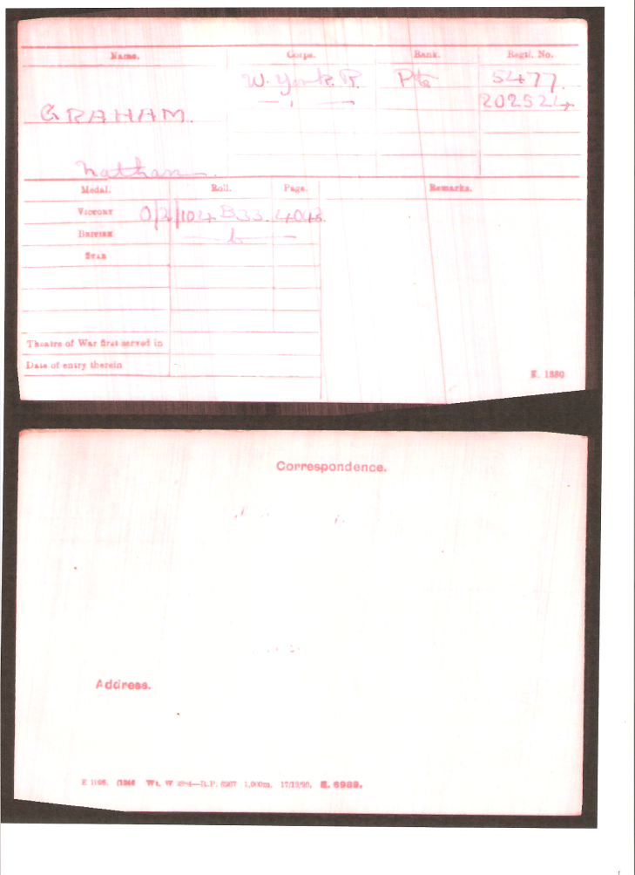
NATHAN GRAHAM’S CAMPAIGN INDEX MEDAL CARD
He is remembered at Commonwealth War Grave AUTHUILE MILITARY CEMETERY, HOOKSTONE MEMORIAL HALL and ST SAVIOUR’S CHURCH, THORNWAITE

