WILLIAM TEAL

Born: September 1888 in HORSFORTH son of Stephen Teal, a stonemason (born in FEWSTON) and his wife Isabell ( born in DACRE)
Siblings: Ada A, born in Dacre, Mary E, born in Guisley
The 1891 census shows William living with his sisters and grandparents’ William and Elizabeth Pullan at ROUNDABOUT FARM, THORNTHWAITE WITH PADSIDE. His mother Isabel is now described as a widow. It is believed her husband died in 1890 and is buried at Fenwick Church, South Yorkshire. She later re-marries Henry Newbould of GREENHOW
In 1901 William is working as 3rd horseman at Haxey near Gainsborough
By the 1911 census William has been married for less than a year to Amy, born in Hunslet, Leeds and they are living in THORNTHWAITE, DARLEY

William was a Private with Prince of Wales’s Own (West Yorkshire) Regiment. He was in the 11th Battalion and his regiment number was 17411.
He died on 7 October 1916 aged 28 and commemorated at Adanac Military Cemetery, Miraumont, France. His War Gratuities of £2.15s3d and £4.10s.0d were paid to his widow, Amy who was living in DACRE BANKS. They had four children, Stephen born in 1911, Thomas in 1912 Amy in 1914 and Elsie May born on 21 April 1916. She would only be six months old when her father died
According to DeRuvigny’s Roll of Honour 1914-1919 William was educated at BRAITHWAITE SCHOOL. He enlisted on 4 August 1915 and served with the Expeditionary Force in France and Flanders and killed in action on the SOMME. Sgt P Mallard wrote “I have always found him a god soldier, always ready and willing to do his duty, and he is a great loss to my platoon. I saw him only a short time before his death, as cheerful as ever under the worst possible conditions”
He was awarded the British War Medal and the Victory Medal

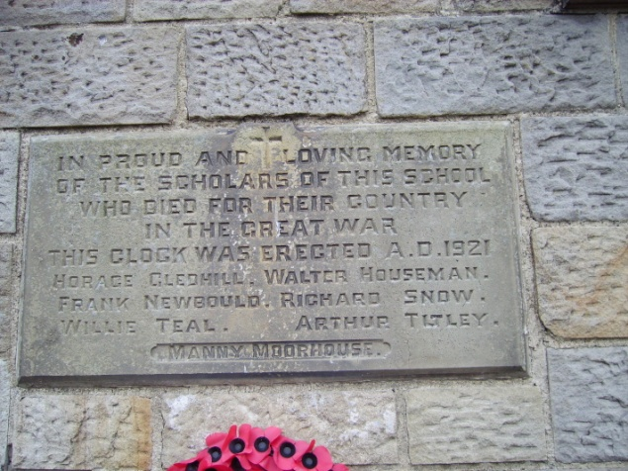

He is commemorated at HOOKSTONE MEMORIAL HALL, DACRE BRAITHWAITE SCHOOL, ST SAVIOURS CHURCH, THORNTHWAITE and ADANAC MILITARY CEMETARY , MIRAUMONT

