WALTER HOUSEMAN

Born: 1888 December quarter (Volume 9a/Page 96 Knaresborough District) in Ripley/Brearton. The eldest child of George (born in Morley) and Emma born in Bishop Monkton
Siblings: Leonard, Rosa, George, and Alice Annie

The 1891 census says Walter and his parents were living in Wooley, Huntingdon. His father is a Farm Bailiff. Walter is aged 2
In 1901 the census shows the family living at Padside Green, Thornthwaite with Padside. Walter is now 12. His father is a farmer and his brothers and sisters have been born
By the 1911 census Walter is a Rural Postman living with his father and one of his sisters in Padside Green. The home has 8 rooms
Walter’s Service Records are available and tell us he was 27 when he enlisted in June 1915. He was 5’7” tall weighing 138 lbs. His girth measures 36 inches
On 7 November 1916 he was posted to the 18th Durham Light Infantry (D.L.I.) and allotted regiment number 6269 and later 301883
His brother George also enlisted and survived the war
Walter was killed in action in France & Flanders on 12 April 1918 aged 29. He was awarded the Victory Medal and British War Medal
At the time of Walter’s death his sister, Rosa was 26 and living in Australia. His other sister Alice, was living in Dacre as were his parents and brothers

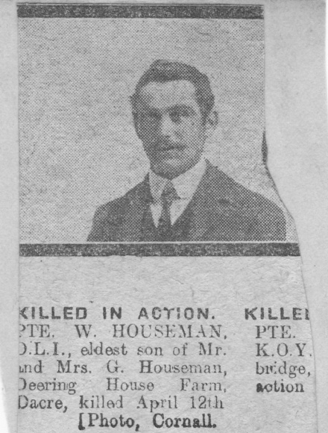

He has no known grave however he is commemorated on the Ploegstereert Memorial to the missing. He is also commemorated on several memorials in the Thornthwaite with Padside district including St Saviour’s Church, Hookstone Memorial Hall and Dacre Braithwaite School
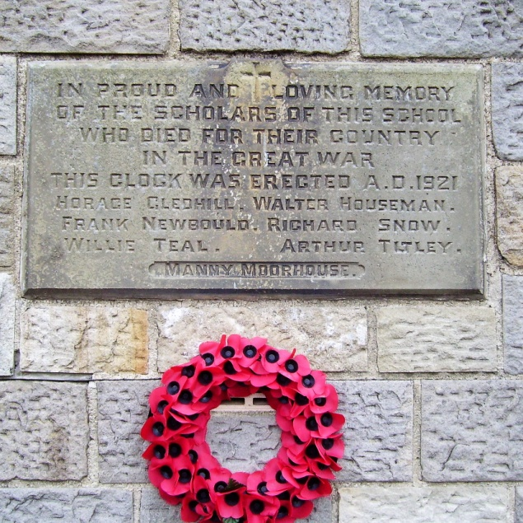
DACRE BRAITHWAITE SCHOOL COMMEMORATIVE PLAQUE

