RICHARD SNOW

Born: September Quarter 1885 (Volume 91/Page 62 Pateley Bridge in THORNTHWIATE WITH PADSIDE. He was the middle of three children, older brother William and younger sister Jane who were born in Thornthwaite. His father William G Snow was born in Dacre and his mother Ann was born in Fellislciffe

The 1891 census shows the family living at NEW HOUSE, THORNTHWAITE WITH PADSIDE. His father is described as a farmer
In 1901 Richard is described as a farmer’s son and his mother is widowed. They were living in PADSIDE

The 1911 census finds Richard at THORNTHWATIE. He is living in a four roomed house with his widowed mother as a mason’s labourer and younger sister who is a farmer’s daughter

Private Snow, service number 4206 West Yorkshire Regiment and then 65194 in the 5th battalion King’s Own (Yorkshire Light Infantry) was awarded the Victory Medal and British War Medal
He was killed on 27 August 1918 aged 33. His War Gratuity of £8.16s11d was paid to his brother William and Sister Jane Bickerdyke as his Executors as was a further £11.0s.0d
The Commonwealth War Graves Commission describes him as the son of William Grange Snow and Ann Snow of MENWITH HILL, DARLEY. He is remembered at GOMIECOURT SOUTH CEMETETRY in France

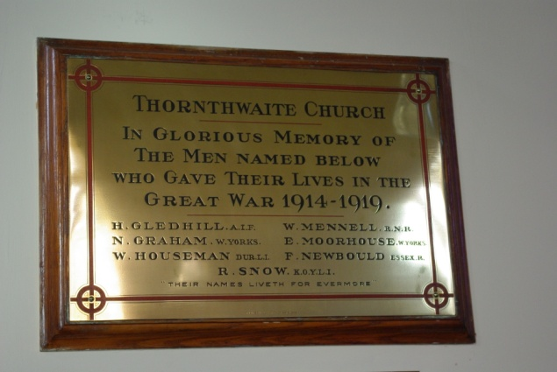
He is also remembered on several local memorials in THORNWAITE WITH PADSIDE and BRAITHWAITE including St Saviour’s Church and Hookstone Memorial Hall

