ARTHUR TULEY
Born: 6 January 1888 in Thornthwaite, the youngest of child of John Tuley of Thornthwaite and Annie (nee Morley and born in Clent, Worcestershire)
Siblings: John born on 10 December 1875 and Mary, born on 28 June 1874 both in Shipley. They were followed by Joseph, born 22 August 1877, William, born on 23 February 1879 in Bewerley, Annie, on 16 October 1880 also born in Bewerley, Emily on 23 September 1882 born at Thruscross, Henry born on 9 April 1884 was born in Thornthwaite. The children were baptised on the same day, 6 February 1888

The 1891 census tells us the family resided at PADSIDE GREEN, THORNTHWAITE. Arthur was 3. Also residing with the family was an Uncle William Tuley aged 70 a widowed retired farmer.

In 1901 the census describes Arthur as aged 13 living with his older brother, John and his wife Annie at CALF CRAGGS, THORNTHWAITE WITH PADSIDE. Their father had died prior to the census. Their mother was living with her daughter Emily and residing in MENWITH WITH DARLEY

The 1911 census finds him at WEST FIELD, HEATHFIELD, PATELEY BRIDGE working as a farm labourer with Mr Myers Beecroft and family. Arthur is 21 and a single man

Prior to enlisting in December 1915 Arthur was a policeman for the North Eastern Railway at Middlesbrough for two years

He served for 6th Battalion Sea Highlanders as Private No: S/12049 enlisting in Middlesbrough. He fought in France for around 10 months from June 1916. He was invalided to Brookdale Red Cross Hospital in Alderley Edge, Cheshire for approximately 3 months
He returned to France in September 1917 and was wounded again on 26 November 1917 and was cared for at a hospital in Etaples as his injury was not serious enough to bring him back to Blighty. He went back to fight a third time at the end of January 1918
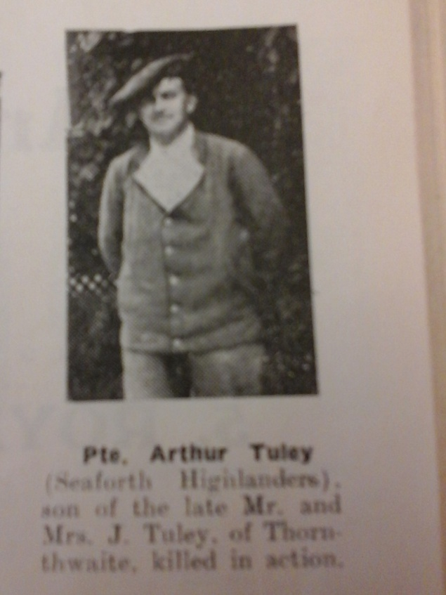
He was killed in action in France & Flanders on the 25 March 1918. He was awarded the Victory and British War Medal and is remembered with honour at Arras Memorial in France. His brothers (apart from John) and sisters received a war gratuity of £1.13s10d each and John received £10

