WILLIAM MENNELL
Born: John William Mennell 13 January 1891 to Johnson Mennell and Beatrice Fletcher. William was baptised on 5 March at St Martin’s Church, Potternewton a suburb of Leeds. Their home address is given as 10 Renfield Grove, Roundhay Road, Leeds
Siblings: None known
The 1891 census tells us he is with his parents at 10 Renfield Grove, East Leeds. His father is described as a dairyman born in GREWELTHORPE his mother in SCOTTON. John W is 2 months old
In 1901 John William is described in the census as aged 10 living with his parents at CARR LODGE, DACRE. His mother is recorded as being born in BURTON LEONARD
The 1911 census finds him at No 1 ALEXANDRE STREET, NORTH TOWN ALDERSHOT as a boarder with Mr and Mrs Styles. William is a butcher
William served as a Private in the Durham Light Infantry, enlisting on 8 September 1914 and transferred to RNVR at Crystal Palace a couple of days later; Anson Battalion. He served as an Able Seaman in the Royal Naval Volunteer Reserve. Kitchener P/940. He is recorded as having a bout of influenza and also of impetigo and myalgia
Certainly at one stage during his service he was working on HMT Aragon Mudros which was classified as his permanent base. This vessel was eventually torpedoed by a German submarine in December 1917 when 610 men killed.
Living at FERNBECK, LOW LANE, DARLEY as was his father, William was 5’4” tall with a brown complexion, light brown coloured hair and grey eyes. He had tattooed flowers on his left fore-arm.

He was killed or died at sea as a direct result of enemy action on Tuesday 6 November 1917 at the age of 26. He had already survived the Dardenelles campaign.
William is remembered at Poelcapelle British Cemetery, Ypres in Belgium number B126. He received 1914-1915 Star, Victory and British War Medals which were given to his mother posthumously.

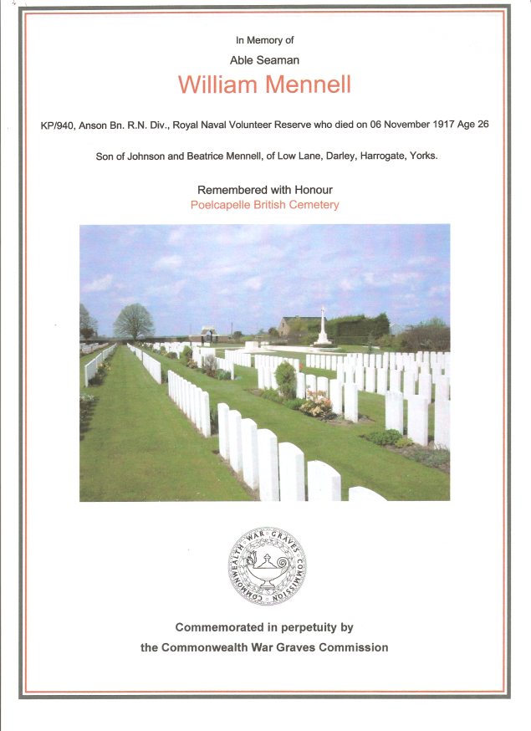

Remembered at
POELCAPELLE BRITISH CEMETERY
HOOKSTONE MEMORIAL HALL,
ST SAVIOUR’S CHURCH, THORNTHWAITE

