MANNEY (EMANUEL) MOORHOUSE

Born: September Quarter 1889 (Volume 9a/Page 64 Pateley Bridge) in THORNTHWAITE to John, a farmer and Sarah Ann
Siblings: Fred, Ernest, Harry, Annie and Grace E. The 1911 census says there were 8 children however the names of the other two are not known
The 1891 census tells us the family resided at HAYSHAW. The family were all born in THORNTHWAITE. John Moorhouse’s wife is called Susannah in this census however it is believed this is an error and it should read Sarah Ann
In 1901 Manney is aged 11 and with his family at HEIGHTS, DACRE
The 1911 census finds him at FOLLY GILL, DARLEY with his parents. Manney was single and working as a warper at a hemp spinning and twine factory
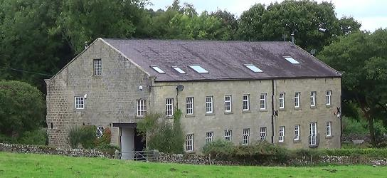
MANNEY MOORHOUSE LIVED HERE IN 1911
Source: peacehavens.co.uk

Manney married MARY SKAIFE in the third quarter of 1915 (Volume 9A/Page 120 Pateley Bridge). They had two children and lived in HEATHFIELD, near WATH. At this time he is working for Mr Atkinson at FOSTER BECK MILL
Private M Moorhouse 76710 joined the Volunteer Army on 30 May 1918. He served with the 4th Battalion, West Yorkshire Regiment (Prince of Wales’s Own). As many soldiers did, he contracted pneumonia and was cared for by Voluntary Aid Detachment Military Hospital in West Hartlepool. This hospital was staffed by less qualified nurses. He died aged 28 on the Wednesday evening of 10 July 1918 from pneumonia. He is remembered with Honour at PATELEY BRIDGE CEMETERY
Further memorials are HOOKSTONE MEMORIAL HALL PLAQUE, ST SAVIOUR’S CHURCH, THORNTHWAITE, DACRE BRAITHWAITE SCHOOL and RAMSGILL MEMORIAL

